PROJECT REPORT

ON

SIMULATION AND EVACUATION OF DULLES AIRPORT PASSANGERS IN EMERGENCY SCENARIEO

SUBMITTED BY

APARNA SENGUPTA
OLUSEYE FADIRAN
PETE VIDAL

NAME OF FACULTY

Dr.Sharad Sharma

BRIEF DESCRIPTION OF PROJECT :- Simulation and Evacuation of Dulles Airport Passenger’s in Emergency Scenario. We will present airport in virtual reality enviorment. DULLES Airport is situated in Chantilly, Virginia, USA .The Airport is 'high at the front, lower in the middle, slightly higher at the back', generated by a rectangular plan. The building is capable of lateral extension."
The building is a highly distinctive building with colonnades of tipped and tapered columns on its two long facades, a gracefully curving roof hung between them, and a pagoda-like control tower nearby,(http://www.greatbuildings.com/buildings/Dulles_Airport.html). Mobile lounges are used to carry some passengers from the terminal to their planes.

GOAL AND OBJECTIVE OF PROJECT :- In the Project we will include –

- "REMODELLING OF PARKING AREA" :- Separate Parking Area for General people, VIP person , and People working at Airport. So that parking area is managed properly with less chaos and better utilizing Time management.

We will be incorporating Building models through various sources ,some of the link’s are (http://www.greatbuildings.com/types/models/spatial_models.html,http://www.huntfor.com/3d/links.htm).

- “ADDITION OF TROLLEIE'S TO CARRY LUGGAGE INSIDE THE AIRPORT” :- For convinance of Passenger's outside the airport, trolley would be their so that they can carry their luggage inside the airport.

- "ADDITION OF COMMON RECEPTION FOR ALL FLIGHT PASSANGER" :- For All flight, their would be common reception where passenger's can get all type of information regarding their flight.

- "EVACUATION INSIDE THE AIRPORT " :-After the Passenger's are inside the airport building, for a particular flight, they will move in same direction to exit from airport building . Mobile lounges will carry some of the passenger's to their flight.

- "EVACUATION IN EMERGENCY SCENARIO" :- In emergency scenario like "Fire Inside the Airport Building"or "Natural Calamities" like "Flood" Passenger's will move towards the exit.

- "PRECAUTION DURING FLIGHT TAKE OFF" :- When flight take off, if it takes a wrong Path or some “Undesirable Object” like "Bird" come's in way of flight then it should stop automatically

MODELLING :- We will be incorporating Building models through various sources ,some of the link’s are (http://www.greatbuildings.com/types/models/spatial_models.html,http://www.huntfor.com/3d/links.htm .
Other model’s in the project like Man, chair, car, Parking Area , podium , Police Man ,Airplane are incorporated through site (http://www.turbosquid.com/). and Bird is incorported through website http://www. images.autodesk.com/adsk/files/3ds_max_2008_animation.exe

Description about model's been used :-

- Main Building :- The terminal was a compact, two-level structure; 600 feet long and 200 feet wide. While it was built without extensions onto the airfield for aircraft loading, it was designed to be expanded up to 320 feet at either end (this expansion was actually completed 34 years later in 1996). The terminal was "topped off" with a distinctive 193-foot high, glass-enclosed, control tower cab which provided the air traffic controllers with an unobstructed view for many miles in all directions.

- Runways :-
Dulles has two north-south parallel runways, each 11,500 feet long, 150 feet wide, and separated by 6,700 feet and a third northwest-southeast runway, 10,000 feet long and 150 feet wide. All runways had standard instrument landing systems (ILS) for landings, high-speed turnoffs to increase runway availability, and the most modern lighting systems. In addition, all runways had paved shoulders, 25 feet wide, ensuring clean surfaces designed to prevent jet engines from ingesting dirt and debris.

- Departure Level :-
Departure level is at same ground level with the Airplane Parking area with a plane landscaping and arrival level is underground (which is not detailed in the presented model).

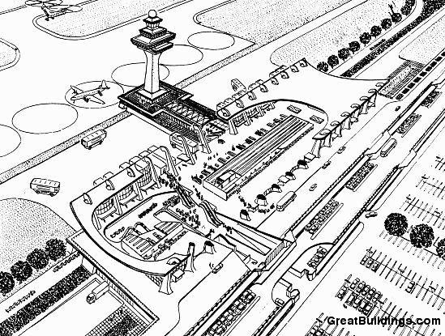

DETAILED AERIAL VIEW OF DULLES AIRPORT

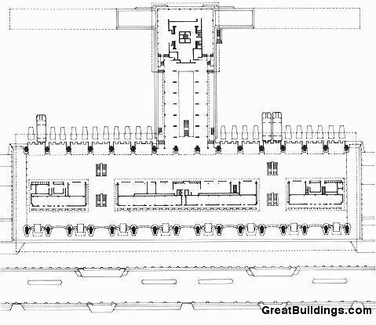

AERIAL VIEW OF DULLES AIRPORT

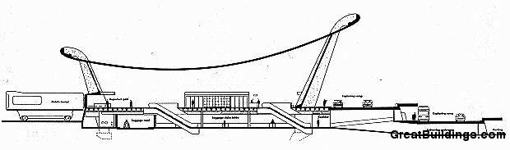

SIDE VIEW OF DULLES AIRPORT

The main building is a four corner building which has a ( ) number of entrance, some of which serve as regular exit for passenger's and all can serve as emergency exit in emergency scenario.

The main building is comprised of set of objects and number of entities. objects include :-
- Man :- Passanger's inside the building.
- Chair :- For the passanger's to sit while they are waiting for thier departure time.
- Podium:- Reception for each and every airways include common reception for helpdesk.
- Policeman:- For Security purpose enforcing safety and parking rules.
- Car :- conveying passenger's to the departure level of airport.
- Direction Banner :- For each and every airways separate banners are thier.
- Tree shaped Parking Area :- For all car's coming in departure level of the airport and to reduce congestion and better time management front of the entrances of the departure building.
- Exit Banner :- Signifies area 's of the building that can be used as exit in normal situation and emergency scenario where all the exit will open for passanger's to move out of the building.
- Airplane :- For the plane take off and plane landing .
- Bouding Box :- Assigned to airplane so that bird dont hit the plane.
- Bird:- used to show the intelligent behavior and animation.

PLANNED GEOMETRY:-

Every object and building is designed using combination of geometries of various
size , some of which are sphere , cylinder , box , plane , line, text etc.

ANIMATION :-

It is divided into two parts :-
- Evacuation inside the building.
- Plane take off .

BEHAVIOR :-

Various behavior are used to show the animation ,they are :-
- Path Constraint behavior :- To show the evacuation of man inside the Airport building.
- Cognitive Controller Editor :- To show the Seek , repel , avoidance - behavior of bird.

APPLICATION USAGE :-

- To visualize a simulated emergency evaculation in airport.
- To visualize all the exits.
- To coordinate emergency airplane landing.

VRML FUNCTIONALITY:-

- Lights :- Directional, point, and spot lighthing used.

- Interpolator's :- Color

- Sensors :- Touch and time sensor

SCOPE OF PROJECT :- The Project is really useful for future development of Airport Parking. Specially taking care of “Undesirable Circumstances” which may cause “Fatal “accident’s, like Bird coming in Path of Aeroplane or While “take off” of flight , it is unable to take correct path. These real time unavoidable circumstances can easy be examined without using real time model’s, where designer has to make quite few changes to over come such situation’s, which are really expensive and time consuming business.

SCOPE OF VIRTUAL REALITY IN THIS PROJECT :- Virtual reality has been a huge boost in the aviation business as it avoids the need to build several different prototypes (models built to the correct size). Every time an engineer designs a new aircraft or helicopter, a prototype has to be built to ensure that it works, whether it will fly fast enough and whether it is safe for the crew and the passengers. If the prototype is wrong, the designers have to go back to

the drawing board, make the changes and then build another one. This is a very expensive and time-consuming business.
By using VR, designers can design, build Airport and test their aircraft in a virtual environment without having to build a real Airport or aircraft. It also allows the designers to try out different ideas - all the ideas can be looked at in detail and they can then select the best one. NASA has used virtual reality to design a helicopter and Boeing have used it to design their latest aircraft.

PROBLEMS ENCOUNTERED :-
- 3ds max file didn't work properly in VRML.
- Modelling took much longer than anticipated .
REMAINING SHORTCOMINGS :-
- Full VRML integration with the 3ds max Studio file is missing due to compatibility issues.
RECOMMNEDATIONS FOR FUTURE IMPROVEMENTS :-
Better integration between 3ds Max and VRML.
SOFTWARE / HARDWARE USED :- 3DS MAX,VRML2.0, XP(Operating System) ,8 GB RAM.

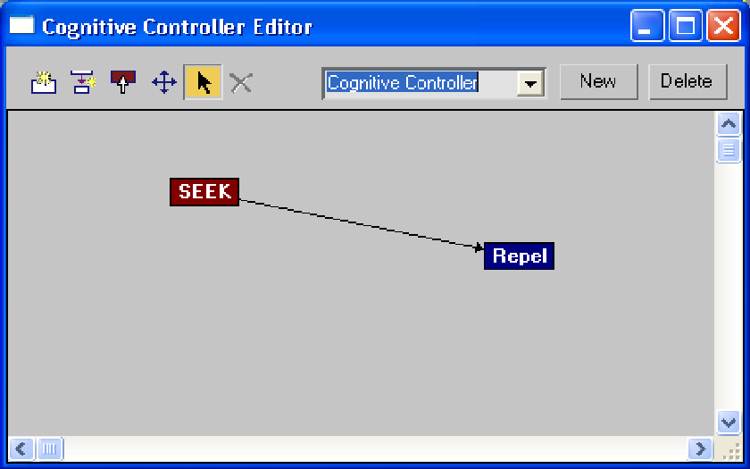

Cognitive Controller Editor

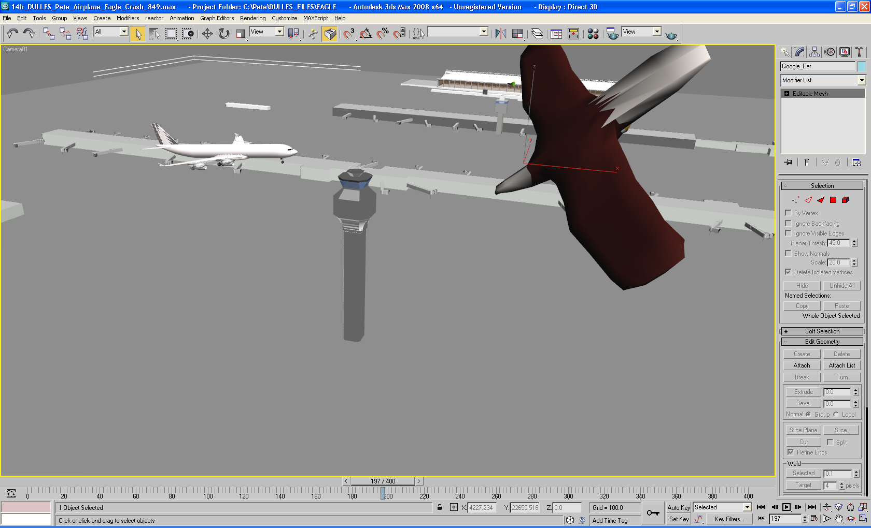

Airport, Airplane, and Bird

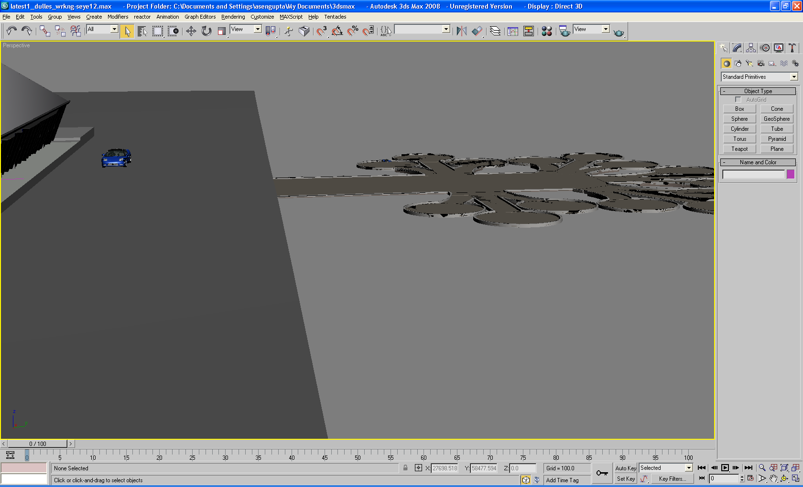

PARKING AREA
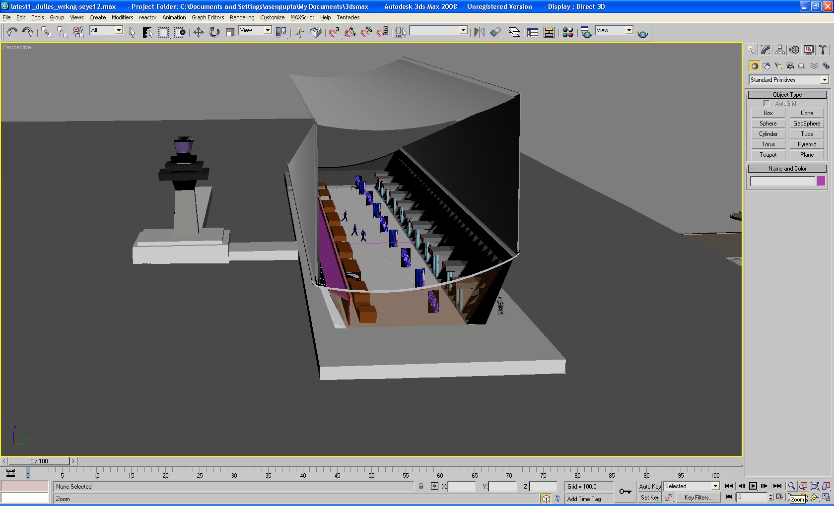

MAIN BUILDING

